Alchocol And Smoke Detection
Nowadays drinking and driving is the most common threat to their as well as others’ life. We cannot stop people from drinking but we can avoid these accidents by checking the person of drinking also we can put these types of small devices in vehicles to assure that no drink and drive can further take place. Today we are going to make a simple alcohol indicator that can be used in small devices or for the demonstration of simple small projects for an Alcohol detector using Arduino.

MQ Sensor:
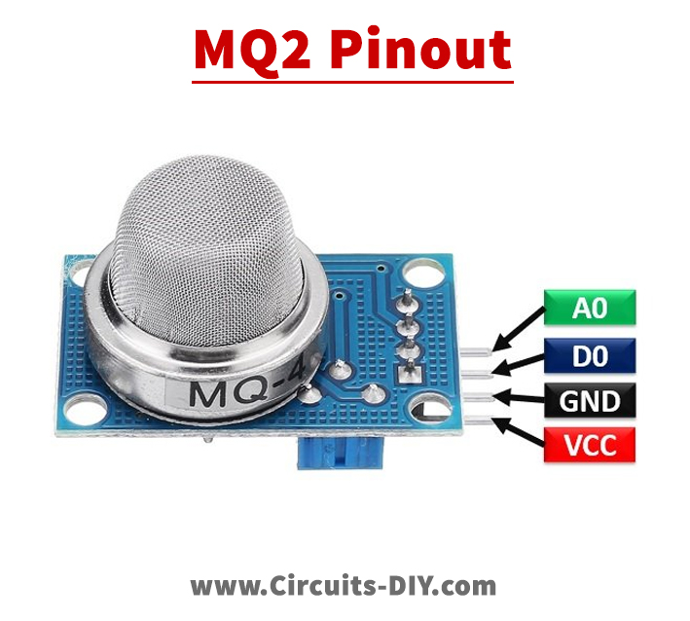

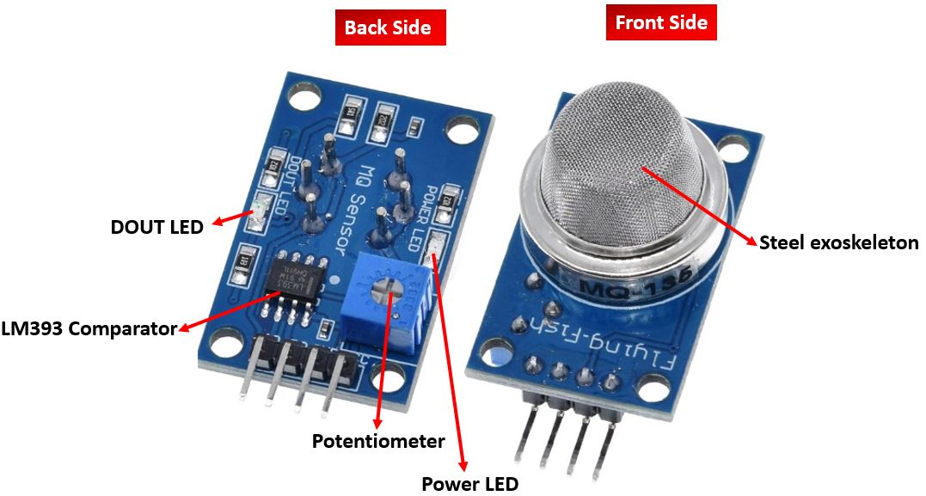
FEATURES AND APPLICATIONS: –
- Sensitivity of Alcohol, Ethanol is good
- Easy to use and fix
- Adjustable value
- Low price
- Can be used in various alcohol detection projects
I2C LCD:
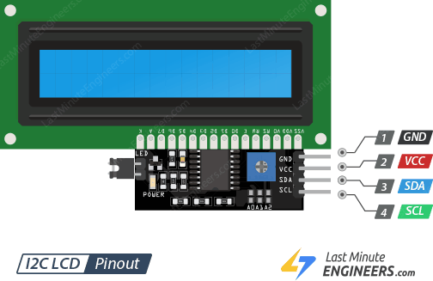
I2C_LCD is an easy-to-use display module, It can make display easier. Using it can reduce the difficulty of make, so that makers can focus on the core of the work. We developed the Arduino library for I2C_LCD, user just need a few lines of the code can achieve complex graphics and text display features.
Arduino Nano:
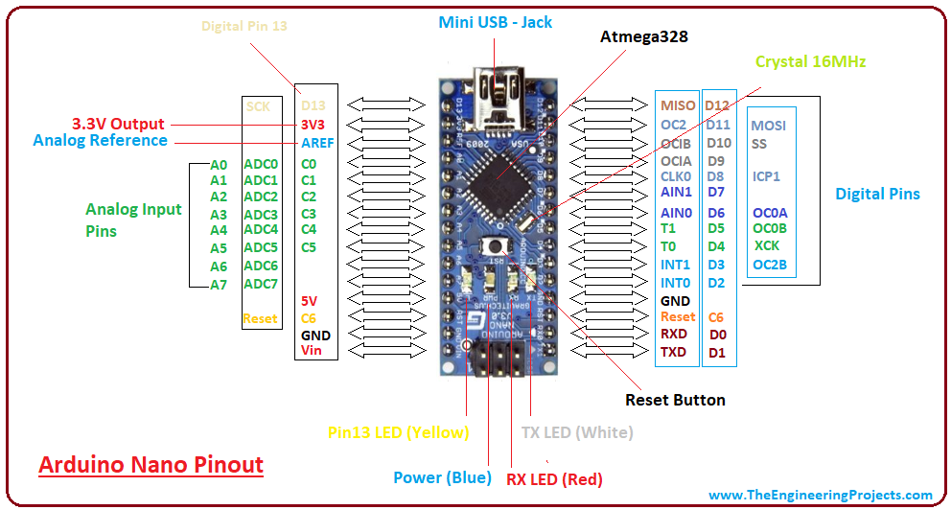

The Arduino Nano is Arduino's classic breadboard friendly designed board with the smallest dimensions. The Arduino Nano comes with pin headers that allow for an easy attachment onto a breadboard and features a Mini-B USB connector.
Input/output:
There are total 14 digital Pins and 8 Analog pins on your Nano board. The digital pins can be used to interface sensors by using them as input pins or drive loads by using them as output pins. A simple function like pinMode() and digitalWrite() can be used to control their operation. The operating voltage is 0V and 5V for digital pins. The analog pins can measure analog voltage from 0V to 5V using any of the 8 Analog pins using a simple function like analogRead().
These pins apart from serving their purpose, can also be used for special purposes, which are discussed below:
- Serial Pins 0 (Rx) and 1 (Tx): Rx and Tx pins are used to receive and transmit TTL serial data. They are connected with the corresponding ATmega328P USB to TTL serial chip.
- External Interrupt Pins 2 and 3: These pins can be configured to trigger an interrupt on a low value, a rising or falling edge, or a change in value.
- PWM Pins 3, 5, 6, 9 and 11: These pins provide an 8-bit PWM output by using analogWrite() function.
- SPI Pins 10 (SS), 11 (MOSI), 12 (MISO) and 13 (SCK): These pins are used for SPI communication.
- In-built LED Pin 13: This pin is connected with a built-in LED. When pin 13 is HIGH – LED is on and when pin 13 is LOW, it is off.
- I2C A4 (SDA) and A5 (SCA): Used for IIC communication using Wire library.
- AREF: Used to provide reference voltage for analog inputs with analogReference() function.
- Reset Pin: Making this pin LOW, resets the microcontroller.
Circuit Diagram: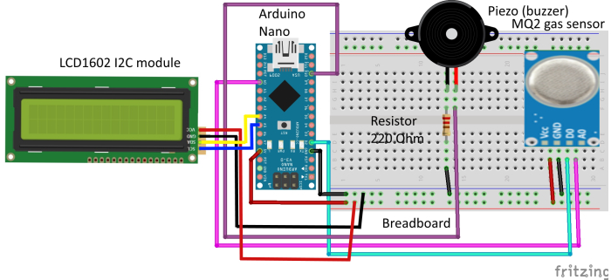
Program:
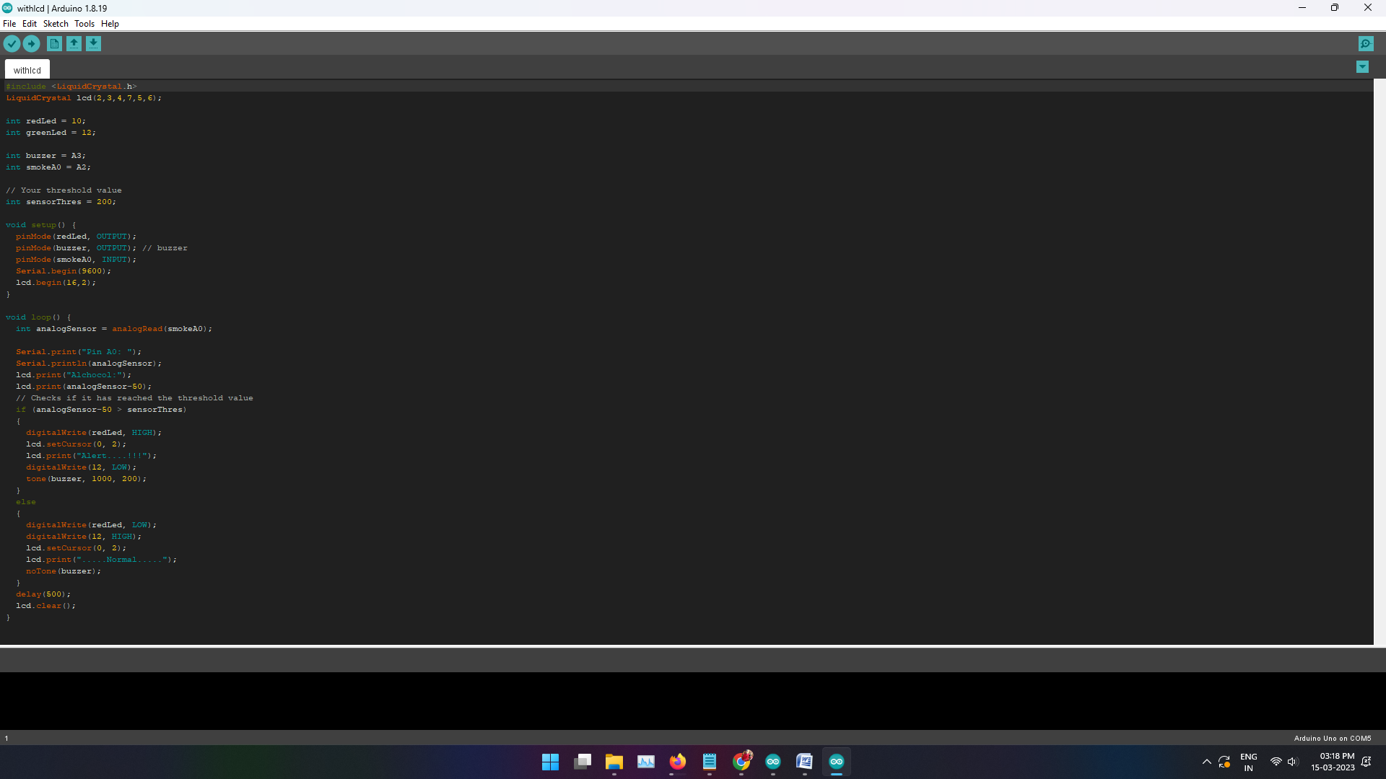

OUTPUT:
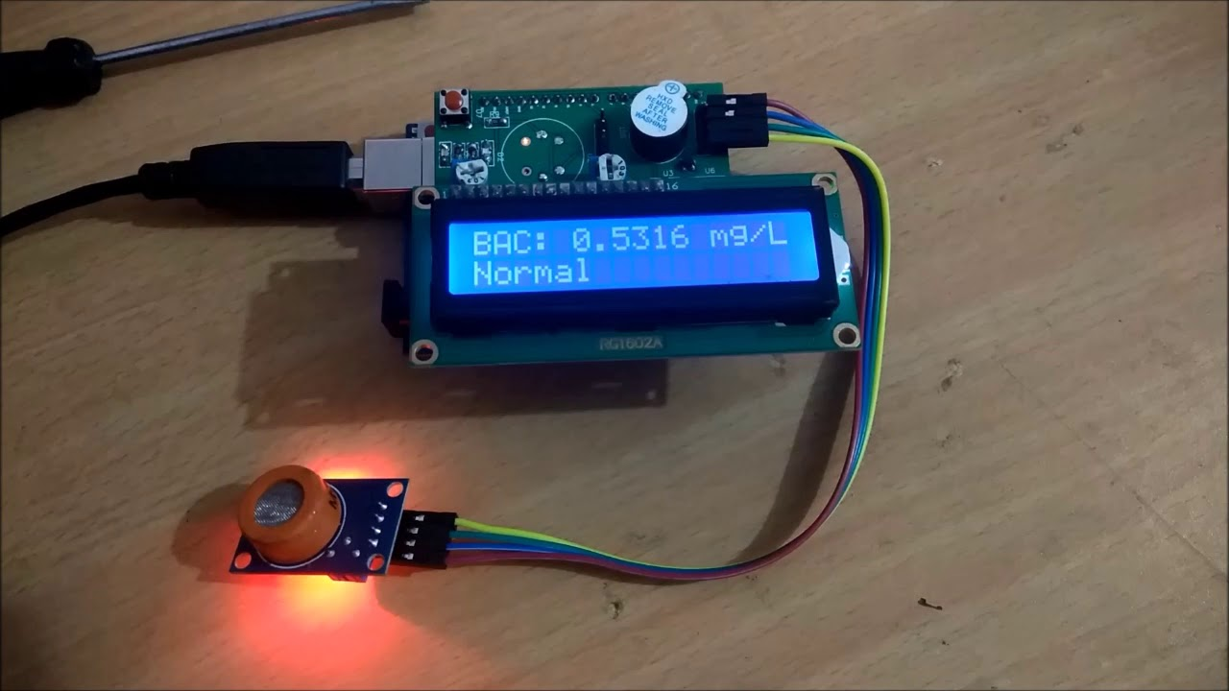

Conclusion:
This paper defines a very real solution to cultivate an smart system for alcohol detection which mainly based on Arduino. The advantage of this system is its range of detection which can be customized as per the requirement of the vehicle and can be placed without getting noticed from accused. The whole embedded system is connected to the vehicle electronic system
which will disable the car ignition system when it is detected that driver is drunk. This is one of the best solutions to reduce number of accidents.

